My First Melody Rubric
Name: _____________
Student’s self score: _______________
Summative/teacher score: /12

(Needs Work: multiple mistakes) (Good: just one or two mistakes) (Perfect: no mistakes)

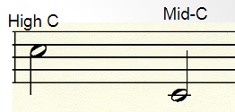
- The piece should use a tonal center of C (does the melody start and end on a c pitch).

1. Needs Work 2. Good 3. Perfect
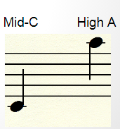
- The piece should have correct pitches. (Does the melody stay within the range of Mid C
to the A above the staff).

1. Needs Work 2. Good 3. Perfect
- The piece should have at least two dynamics markings added.

1. Needs Work 2. Good 3. Perfect

- The piece should have at least 4 (8 if you have played an instrument for more than a year)

1. Needs Work 2. Good 3. Perfect

